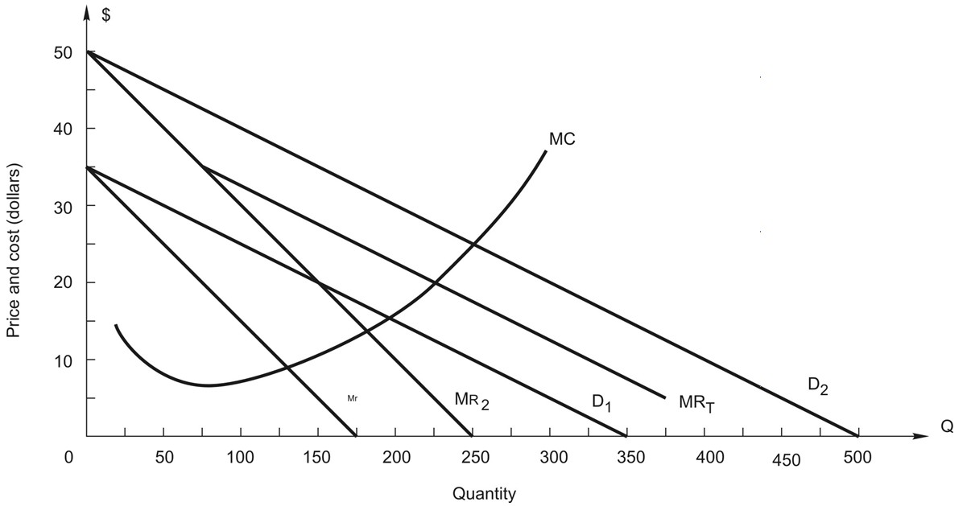
The next 5 questions refer to the following figure:
The graph shows the demands and marginal revenue in two markets, 1 and 2, for a price discriminating firm along with total marginal revenue, MRT, and marginal cost.
- What total output should the firm produce?

- 275 units
- 225 units
- 175 units
- 350 units
- 100 units
- How should the firm allocate sales between the two markets?

- 150 in each market
- 100 in market 1, 175 in 2
- 150 in market 1, 300 in 2
- 112.5 in each market
- 75 in market 1, 150 in 2
- What price should the firm charge in each market?

A. P1 = $20, P2 = $32.50 B. P1 = $35, P2 = $22.50 C. P1 = $20, P2 = $20
D. P1 = $27.50, P2 = $35
E. Impossible to say because market demand is not given

- At the optimal price and quantity, what is demand elasticity in each market?

A. E1 = -3.67, E2 = -2.33 B. E1 = -3, E2 = -4
C. E1 = -2.5, E2 = -3.5 D. E1 = -3, E2 = -3
E. E1 = -1.67, E2 = -2.33

